UML DIAGRAM OF THE PROJECT:

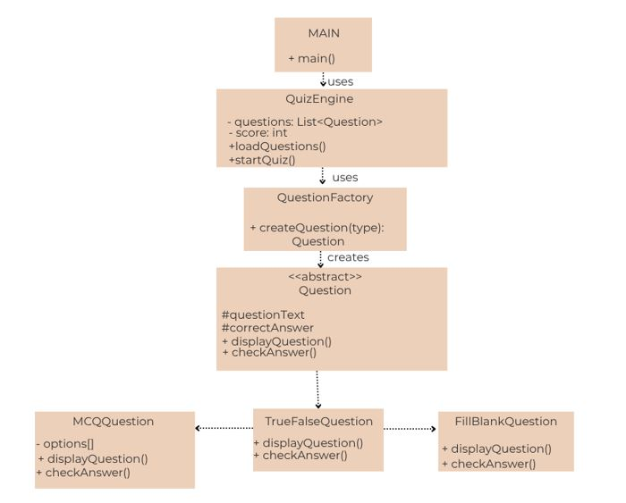
This diagram illustrates how the abstract Question class is extended by specific question types such as MCQQuestion, TrueFalseQuestion, and FillBlankQuestion, demonstrating inheritance and polymorphism. The diagram also shows how QuizEngine, QuestionFactory, and Main interact to create questions, manage the quiz flow, and execute the application.

